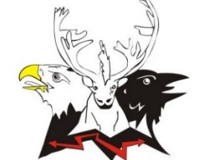
Native Village of Chitina
PO Box 31, Chitina, Alaska 99566
(P) 907-823-2215
(E) caketcham@chitina.org

June 28, 2023

Dear Tribal Citizens,

I am working on updating tribal members’ contact information. Some of our tribal members are unreachable due to moving, changing phone numbers, etc. Our goal is to reach all our tribal members, so they are receiving updates of our services, opportunities, and events from Native Village of Chitina (NVC). We are asking you to complete a contact form. Also, we are asking you to complete a new family tree form. This family tree form has been updated to add your clan. If you return the forms by August 31, 2023, you will be entered into a drawing.

5 Drawings for all tribal citizens who fill out both forms!

1st Drawing: $100
2nd Drawing: $100
3rd Drawing: $100
4th Drawing: $100
5th Drawing: $100

Please spread the word to all our Chitina tribal members to help NVC reach all our tribal members. Our mail and email addresses are shown at the heading of the letter. You may submit your forms either by mail or email. Of course, if you are coming to the hall by the deadline, you may drop them off at the hall. If you are unable to scan your forms and email them, you can take a picture and email the forms. If you know someone that needs the forms, please contact us immediately. As always, please contact me for any questions.

Tsin’aen (Thank you),

Colleena Ketcham
Tribal Enrollment

